Standard Operating Procedure for:  Cleaning glassware | PPE required:      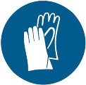
Glassware (not volumetric) should be cleaned, dried, and put away after every use. Plastic ware can also be cleaned but please ensure that the plastic will not degrade on exposure to acid. Your choice of acid will depend on the type of experiments you are doing. This SOP covers making up to 10% v/v hydrochloric acid or nitric acid baths. Minimum PPE is lab coat, safety glasses, and two pairs of gloves. These are required as you are handling concentrated acid and there is a potential for broken glass. As such use nitrile and neoprene gloves (nitrile underneath).
Cleaning glassware  - Wash glassware with tap water and Decon-90 if glassware is particularly contaminated – DECON-90 is corrosive to non-ferrous metals.  - Open 10% acid bath keg in fume cupboard using neoprene gloves and add you glassware ensuring appropriate surfaces are covered. Clean up any acid spills.  - Close acid bath and place in appropriate spill tray and leave overnight (no longer than 24 hours).  - Open 10% acid bath in fume cupboard using neoprene gloves and remove you glassware into bowl provided. Clean up any acid spills.  - In a sink, rinse glassware 3-4 times with deionized water and leave to dry.  - Return next day to put glassware away.  Refreshing acid bath  If acid bath is contaminated or over 1 year old please refresh.  - To empty the acid bath, siphon the acid from the keg into empty plastic waste bottles using the siphon pump provided. Do this in the fume hood using neoprene gloves. Clean up any acid spills.  - Wipe down surface of bottles, label with contents and your name, and place in appropriate spill tray. Wash out siphon with water.  - Add appropriate volume of deionised water to keg (see table).  Vol. of keg (L) Max vol. of water (L) Max vol. of acid (L)  10 5 0.5  15 7 0.7  20 10 1  26 13 1.3  - In fume hood using neoprene gloves add concentrated acid depending on desired volume (see table). Clean up any acid spills. ALWAYS ADD ACID TO WATER.  - Write your name, the date you made acid bath and type of acid (and concentration) on top of keg and on side then place back in tray provided. | Hazard symbols:  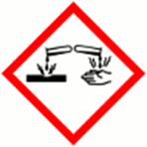  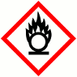  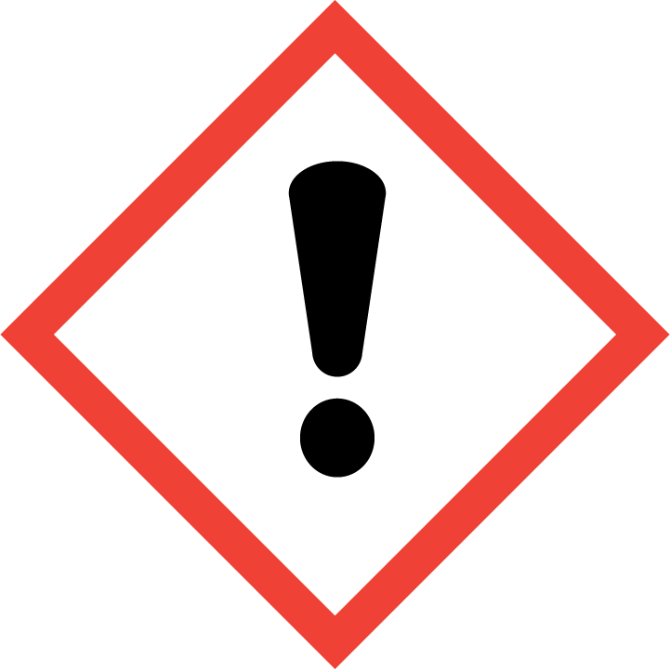
Significant hazards:
Concentrated hydrochloric and nitric acid.
DECON-90
 | Hazard phrases (H): H272, H290,H314, H319,H335
Can it be done out of hours?

Glassware can be left in containers out-of-hours but containers should not be opened out-of-hours.
This SOP is not relevant in the following circumstances:
- Contents of acid bath or glassware are radioactive or biocontaminated.
- Any acids are used other than nitric or hydrochloric acids.
- Any others situation where the procedure may result in harm to yourself or others.

