Standard Operating Procedure for:  Reusing plastic bottles | PPE required:      
In order to reduce Cohen’s plastic waste all Nalgene bottles of volume >60ml should be cleaned and reused where possible. Plastics vessels with 60ml or less can be disposed of through the orange bag waste route. Cleaning should be a minimum of an overnight soak in 10% v/v acid (hydrochloric acid or nitric acid) then rinsed, dried, and put away after every use. Your choice of acid will depend on the type of experiments you are doing. Decon-90 can also be used as a pre-wash before rinsing and soaking.
Minimum PPE: lab coat, safety glasses, and doubles gloves (at least one pair should have longer cuffs)
Cleaning plastic containers  - Clean off any markings using appropriate solvent (e.g. ethanol)  - Wash plastic containers with DI water (and Decon-90 if containers are heavily contaminated) DO NOT USE ABRASIVE CLEANERS OR SCOURING PADS.  - Decon-90 is biodegradable, phosphate-free, bactericidal, non-flammable and totally rinsable.  - If bottles do not appear clean after a Deon-90 rinse then they can be disposed of.  - Open a 10% acid bath keg in fume cupboard using chemical resistant gloves and add you plastic containers ensuring appropriate surfaces are covered. Clean up any acid spills.  - For larger vessels (e.g. 1L) 10% acid should be added to vessels and vessels appropriately labelled.  - Close acid bath and place in appropriate tray and leave overnight (no longer than 24 hours).  - Open 10% acid bath in fume cupboard using chemical resistant gloves and remove you plastic containers into bowl provided. Clean up any acid spills.  - In a sink, rinse glassware 3-4 times with deionized water and leave to dry (max 60ºC)  - Return next day to put containers away in appropriate location.  Vol. of keg (L) Max vol. of water (L) Max vol. of acid (L)  10 5 0.5  15 7 0.7  20 10 1  26 13 1.3  Refreshing acid bath  If acid bath is contaminated or over 1 year old please refresh.  - To empty the acid bath, siphon the acid from the keg into plastic waste bottles using the siphon pump provided. Do this in the fume hood using chemical resistant gloves. Clean up any acid spills.  - Wipe down surface of bottles, label with contents and your name, and place into waste cupboard. Wash out siphon and keg with DI water.  - Add appropriate volume of deionised water up to keg (see table).  - In fume hood using chemical resistant gloves add concentrated acid depending (see table). Clean up any acid spills. ALWAYS ADD ACID TO WATER.  - Write your name, the date you made acid bath and type (and concentration) of acid on top of keg and on side then place back in tray provided. | Hazard symbols:  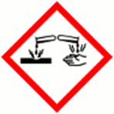  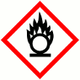  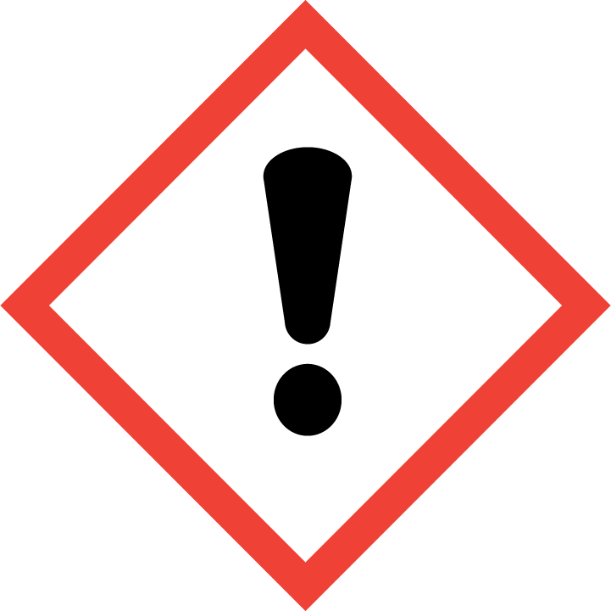  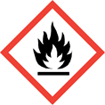Solvent
Significant hazards:
Concentrated hydrochloric and nitric acid.
Hazard phrases (H):
H272, H314, H335
Can it be done out of hours?
Bottles can be left in kegs out-of-hours but kegs should not be opened out-of-hours.
This SOP is not relevant in the following circumstances:
- Contents of acid bath or containers are radioactive or biocontaminated.
- Any acids are used other than nitric or hydrochloric acids.
- Any others situation where the procedure may result in harm to yourself or others.

