Standard Operating Procedure for:  Using centrifuges | PPE required:      
When using the centrifuge do not place any item within 6 cm of any centrifuge and that, where appropriate, rotor tie-down devices are securely fastened. Use only the rotors and accessories designed for the centrifuge and do not exceed the maximum rated speed of the rotor. NEVER attempt to slow or stop the rotor by hand. Always check tubes are suitable for using in the centrifuge.
NEVER try to open the centrifuge while the rotor is spinning or run the centrifuge with the door open unless it is in the zonal mode (available with certain centrifuges). In the event of a power failure, do not attempt to retrieve the sample from the centrifuge for at least one hour and contact a technician. When glass tubes are run, be careful if these tubes break inside the chamber bowl. Examine and clean the gasket and/or chamber bowl with care because glass fragments may have become embedded in them.
Loading the centrifuge  For runs at other than room temperature, refrigerate or warm the rotor beforehand for fast equilibration. For low-temperature runs, precool the centrifuge by running a 30-minute cycle (with a precooled rotor installed) at the desired temperature with the speed set at 2000 rpm.  - Press the POWER switch to on (I). Open the centrifuge by pressing one of the following and then lifting the door up:  - Beckman: [OPEN DOOR]  - Eppendorf: [open]  - Sigma: Yellow button  - Install the rotor according to the instructions in the appropriate rotor manual. Always run the rotor with a balanced load. Ensure tubes are of equal weight within 3%.  - Close the centrifuge door and push firmly down on it until you hear both latches engage.  Running the centrifuge  Beckman 64R Eppendorf 5810 Sigma  Select a rotor number: [ROTOR], [▲] or [▼], [ENTER]  Set run speed: [RPM], [▲] or [▼], (or) [RCF], [▲] or [▼], [speed] once, [▲] or [▼], (press [speed] again for RCF or RAD) Rotate RH blue button  Set run duration: [TIME], [▲] or [▼], [time] once, [▲] or [▼] Rotate LH blue button  Set run temperature: [TEMP], [▲] or [▼],  Select acceleration curve (0 through 9): [ACC], [▲] or [▼], [time] twice until appears, [▲] or [▼]  Select deceleration curve (0 through 9): [DEC], [▲] or [▼], [time] 3 times until appears, [▲] or [▼]  - Check that all parameters are correct and the door is shut and latched.  - Beckman: Press [ENTER], then [START].  - Eppendorf: [start/stop]  - Sigma: Green button  - Wait for the set time to count down to zero, or end the run by pressing:  - Beckman: [STOP] or [FAST STOP]  - Eppendorf: [start/stop]  - Sigma: Red button  - After the rotor stops spinning and the OPEN DOOR light comes on, press on of the following to release the door latches; open the door:  - Beckman: [OPEN DOOR]  - Eppendorf: [open]  - Sigma: Yellow button  - Clean interior of centrifuge and rotors of any chemical residue and unload the rotor, if required, according to instructions in the appropriate rotor manual.  Caution Beckman ONLY: if the message SEr appears on the display, do not press any keys while the message is displayed. Turn the centrifuge power off (O) and back on (I) to clear the message. | Hazard symbols:  See individual experiment risk assessments
Significant hazards:

See individual experiment risk assessments

 | Hazard phrases (H):
Can it be done out of hours?

Centrifuges should not be used out of hours.
This SOP is not relevant in the following circumstances:
- SOP does not cover specific experimental risk these must be covered by user’s assessments
- Any other situation where the procedure may result in harm to yourself or others.

Standard Operating Procedure for:  Centrifuge maintenance |  |  | PPE required:
You must be trained in centrifuge operation and maintenance before carrying out maintenance of a centrifuge.
Centrifuge maintenance is critical to keep centrifuge users safe. The centrifuges that require regular (monthly) maintenance are Sigma 2-16 (9.129), Eppendorf 5810 (9.136), Sigma 4-16KS (9.134), and Thermo IEC CL10 (8.130a). Other smaller centrifuges do not require this. All centrifuges receive annual or biannual professional maintenance.
If the centrifuge is particularly unclean report this to a technician as this is unacceptable and the user responsible must be warned.
 | 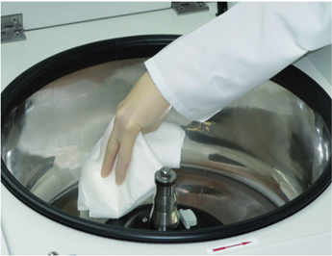 | - Carefully unscrew the shaft and remove the rotor.  - Wipe the inside of the centrifuge clean with water and dry.  - Clean all accessories (buckets and inserts) with water. Leave to dry. | Hazard symbols:  N/A
 | 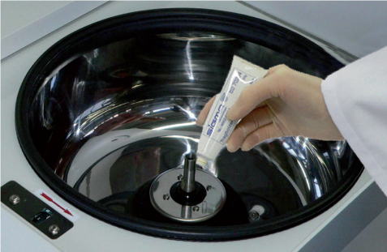 | - Check all parts for cracks, visible damage of the surface, signs of corrosion. Report any issues to a technician.  - Spray the inside metal surface of the centrifuge with PTFE spray to protect against corrosion.  - Grease the motor shaft with a very small amount of grease and spread with a cloth. | Significant hazards:  N/A
 | 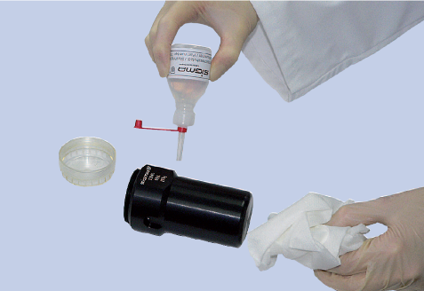 | - Once the metal buckets have been cleaned and completely dried apply small amounts of slushing oil with paper towel to the aluminum rotors and buckets. This helps protect against corrosion.  - Replace the rotor and screw the shaft back in place – do not overtighten. | Hazard phrases (H):  N/A
 | 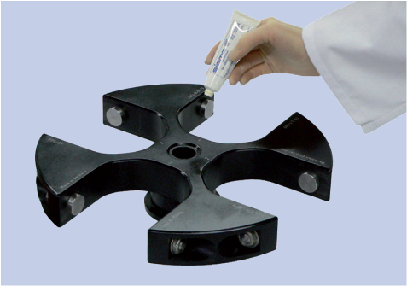 | - Grease the load-bearing bolts of the rotor. About quarter to half a pea size amount of grease on each depending on the size of the bolt.  - Replace the buckets and move to spread the grease. | Can it be done out of hours?  Centrifuges should not be maintained out of hours.
Products: Slushing oil (VWR: SIGM70104), general purpose grease (RS: 556-446), and PTFE dry film lube spray (132-469).
This SOP is not relevant in the following circumstances:
- SOP does not cover specific experimental risk these must be covered by user’s assessments
- Any other situation where the procedure may result in harm to yourself or others.

