Standard Operating Procedure for:  Degassing liquids | PPE required:      
For many experiments it may be desirable to reduce the amount of dissolved oxygen and other dissolved gases in solution. There are four main methods: pressure reduction, heating, sonication and displacement by an inert gas (sparging). Sparging will be discussed here. The technique below is described used nitrogen, however, argon or helium could also be used. DO NOT use the same degassing bottles for reagents, acids and water. Diagrams below show two possible set ups for degassing. This SOP can be used for degassing water, for any other substance an addition risk assessment is required.
This technique is not suitable for volatile chemicals or where undesired chemical reactions or decompositions may take place. You should make your own assessment of this and any other risks from the chemicals you are using.  - Put your liquid into a clean Dreschel bottle (or another container with a narrow opening) with a gas distribution tube (porosity 2) or similar and a clean magnetic stirrer. See diagrams below.  - Put it onto a hotplate/stirplate and connect it to zero grade nitrogen cylinder (BASIC GAS CYLINDER TRAINING REQUIRED). To avoid any water flowing back into the N₂ cylinder use a small collector flask between the cylinder and the Dreschel bottle.  - Carefully turn on the flow of gas – ensure there is a flow controller after regulator  - Optional: To decarbonate gas place a bottle containing 10M NaOH before liquid to degas (see diagram – should also be a small collector flask before this – not shown) Double glove and use fume cupboard when handling NaOH as highly corrosive.  - Optional: Bring the liquid to the boil (or heat for a length of time) with low N₂ flow rate; after the liquid is boiling decrease the temperature and increase the N₂ flow rate. (BEWARE HOT LIQUID). To avoid burns vent must go to a separate flask.  - Leave gas flow for 30mins (for 500 mL) or longer as required. Place sign with a warning of hot liquids and surfaces.  - Cool the liquid to room temperature under constant N₂ flow.  - After stopping the N₂ flow IMMEDIATELY close the bottle using parafilm.  - If using in the anaerobic chamber transfer it into the chamber within MINUTES. Remember to make a small hole on the parafilm right before the outside door of the airlock is closed. Then transfer to an airtight glass bottle but leave in chamber for overnight without tightening lid to allow removal of any remaining oxygen.  - When the bottles are not in use cover them with parafilm to avoid contamination.  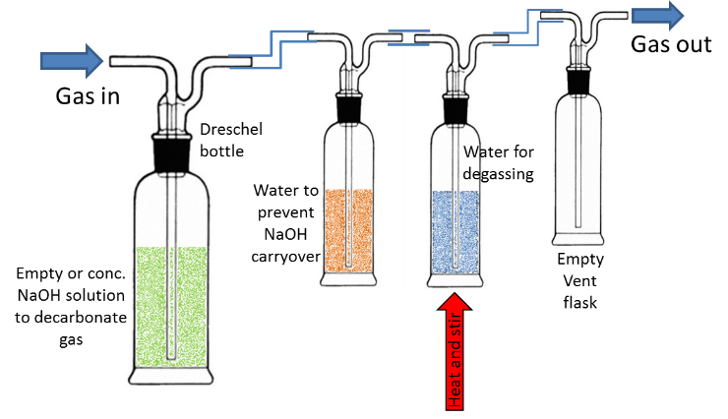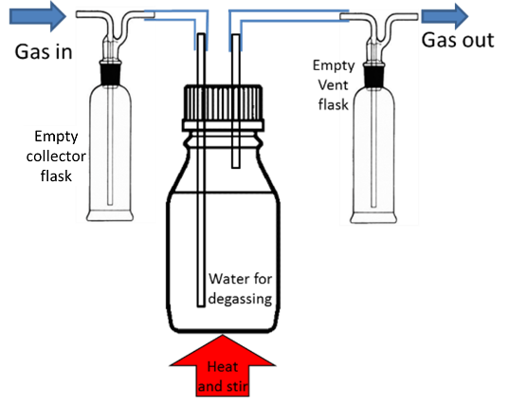 | Hazard symbols:  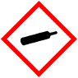  If using NaOH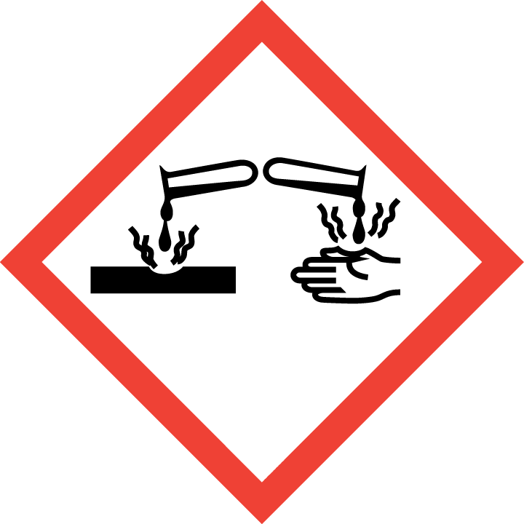
Significant hazards:
Compressed gas cylinders.
Hot liquids and surfaces burn risk.
NaOH
Hazard phrases:
H280

Can it be done out of hours?

This activity cannot be done out of hours due to use of cylinder gases
This SOP is not relevant in the following circumstances:
- SOP does not cover specific experimental risk these must be covered by user’s assessments
- Any other situation where the procedure may result in harm to yourself or others.

Standard Operating Procedure for:  Degassing liquids - sonication | PPE required:
For many experiments it may be desirable to reduce the amount of dissolved oxygen and other dissolved gases. There are four main methods: pressure reduction, heating, sonication and displacement by an inert gas (sparging). Only sonication will be discussed here.
This SOP can be used for degassing water, for any other substance an addition risk assessment is required.
Cold sonication  This technique is suitable for many volatile and reactive chemicals; however, you should make your own assessment of this and any other risks from the chemicals you are using. SOME CHEMICALS MAY GET HOT DURING THIS PROCESS which can result in an EXPLOSION.  - Put your liquid into a clean bottle (or another container with a narrow opening) with a loose fitting lid or covering.  - Make sure the sonic bath is filled up to the appropriate level,  - Put it into a sonic bath and commence sonication for desired time.  - Once sonication is complete IMMEDIATELY tighten the lid on the bottle or seal using parafilm.  Heated sonication  This technique is not suitable for volatile chemicals or where undesired chemical reactions or decompositions may take place. You should make your own assessment of this and any other risks from the chemicals you are using.  - Put your liquid into a clean bottle (or another container with a narrow opening) with a loose fitting lid or covering. Beware of lids from volumetric flasks popping off.  - Make sure sonic bath is filled up to the appropriate level,  - Put it into a sonic bath and commence sonication. Set the temperature of the bath to an appropriate temperature. Place sign to warn of hot liquids.  - Reduce temperature back to ambient continuing sonication throughout,  - Once ambient temperature is reach and sonication is complete IMMEDIATELY tighten the lid on the bottle or seal using parafilm. | Hazard symbols:  Other hazards from individual experiments
Significant hazards:
Noise from sonicating bath
Burst blood vessels from contact with sonication
Other hazards from individual experiments
 | Hazard phrases:
Can it be done out of hours?

Degassing by sonication can be performed out of hours so long as risk assessment of individual experiments allow.
This SOP is not relevant in the following circumstances:
- SOP does not cover specific experimental risk these must be covered by user’s assessments
- Any other situation where the procedure may result in harm to yourself or others.

