Standard Operating Procedure for:  Using Carbolite ashing furnace | PPE required:      
This SOP the use of the Carbolite 1000-1200ºC ashing furnace.

When operating furnaces PPE is required including laboratory coat, safety glasses and nitrile gloves. For higher temperatures thermally insulating gloves are required.

Never put flammable or volatile materials in the furnace. Never put measuring glassware in the furnace (e.g. volumetric flasks and measuring cylinders).

Before use  - TURN ON THE EXTRACTION HOOD!  - Ensure that the temperature of the oven does not exceed the melting or boiling point of any materials to be placed in the oven.  - Polystyrene melting point = 70 ^{º}C  - Polypropylene melting point = 130 ^{º}C  - Aluminum = 660 ^{º}C  - If there is any concern of your sample producing toxic emissions or unpleasant smells please consult a technician. Never put flammable materials in ovens/furnaces.  Adding items to furnace  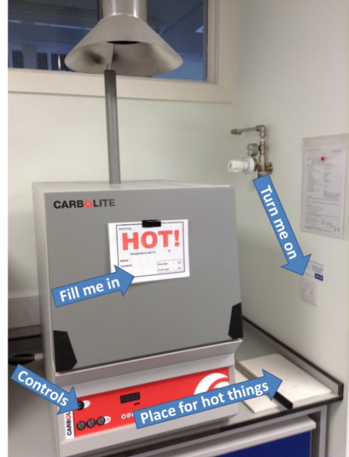  - Make sure you are wearing protective heat proof gloves when adding items to furnace  - Ensure door is firmly shut when items in furnace.  - Write on door label:  - Start and finish date,,  - Full name,  - Temperature,  - Whether other users can use the furnace at the same time,  - Any other important sample information for users (e.g. toxicity).  - Check on sample after around 30mins to ensure no unpleasant emissions are being released and that samples are not burning.  Removing items from furnace  - When removing hot items from the furnace ensure you use the protective heat resistant gloves provided.  - For higher temperatures please use heat resistant mats to avoid damaging work surfaces.  - If your samples are in the oven past the date on the front they may be disposed of without warning.  Furnace controller  To set a simple ramp, hold and cool please follow the instructions below. For more complex programs please speak to a technician.  - Put the furnace into “Hold mode”  - Press the Page key once so it reads SP°C then use arrow keys to set the Set Point.  - Press the Page key again so it reads SPrr then use arrow keys to set the Ramp Rate (normally 10 max. 20ºC/min.).  - Press the Page key again so it reads t1 then use arrow keys to set the Dwell time  - Press the Page key again so it reads HOLD then press the Timer Key to start the program.  Hold mode Page key Arrow keys Timer key | Hazard symbols:  See individual users risk assessment
Significant hazards:
- High temperatures

Hazard phrases (H):
See individual users risk assessment

Can it be done out of hours?

The ovens and furnaces can be used out of hours.
This SOP is not relevant in the following circumstances:
- SOP does not cover specific experimental risk these must be covered by user’s assessments
- Any other situation where the procedure may result in harm to yourself or others.

