Standard Operating Procedure for:  Handling HF | PPE required:      
Introduction
Working using Hydrofluoric acid (HF) should only be carried out if there is no safer alternative. HF can cause death through hypocalcaemia. It can cause severe burns and blistering which may not be immediately painful or visible with symptoms potentially delayed 12 - 24 hours after exposure. Expose of any kind requires hospital treatment.
Before starting work you must have undergone training and safety awareness in handling and using HF and risk assessed your experiment. The minimum protection required is a laboratory coat, two pairs of gloves (gauntlet nitrile gloves and gauntlet neoprene gloves), safety glasses, an apron, and a face shield. All work should be carried out in a specifically designed fume cupboard.
HF should never be stored in glass containers, or with incompatible chemicals. The only chemicals that should be stored in the HF fume hood are saturated sodium bicarbonate solution, and perchloric acid. These in a chemical resistant drip tray.
Preparing for work  Ensure you have risk assessed your experiment making reference to this assessment and ensure you are wearing all appropriate PPE (see above).  - Inform your named person that you are about to work with HF; never work alone.  - Put signs up to let others know HF work is in progress, and tell anyone else working in the lab that HF work is in progress,  - Make sure that calcium gluconate gel is available in the local first aid kit,  - Check that the HF fume hood is working and that the test certificate is in date, turn extract and scrubbers on  - Check integrity of PPE including a check of the gloves for pin holes,  - Check there is sodium bicarbonate solution for neutralising spills and washing down PPE before removal and check a spill kit is available,  - Use secondary containers if you have to transport large quantities of HF (max. 2.5L).  During work  - Only use the ceramic HF dispenser to dispense HF and then only sufficient quantity for immediate use.  - Any spillage should immediately be neutralised with sodium bicarbonate solution  - Make sure there is a chemically resistant spill tray under the working area.  - If you have to decant HF from a larger bottle (max 1L) into the 2.5L dispensing bottle this must be done with another person present in full PPE.  After work  - Wipe down all equipment and surfaces with a solution of saturated sodium bicarbonate followed by water. Water should be left running in fume cupboard for 12 hours after use.  - If practicable, and safe to do so, neutralise excess HF liquid with sodium bicarbonate  - Neutralise the gloves and the working space with saturated sodium bicarbonate and rinse the gloves with copious amounts of water  - If work is to be run overnight, always close the fume cupboard sash and place the appropriate signage on the fume cupboard and external laboratory door(s).  - Dispose of waste material through the appropriate waste streams ensuring all possible HF contamination has been neutralised,  - Remove unnecessary signage from the fume hood and doors.  - Inform your named person(s) that you have completed the work and if you have left anything to run overnight.  - If not leaving work overnight turn off scrubbers (not extract) and run backwash 30mins | Hazard symbols:  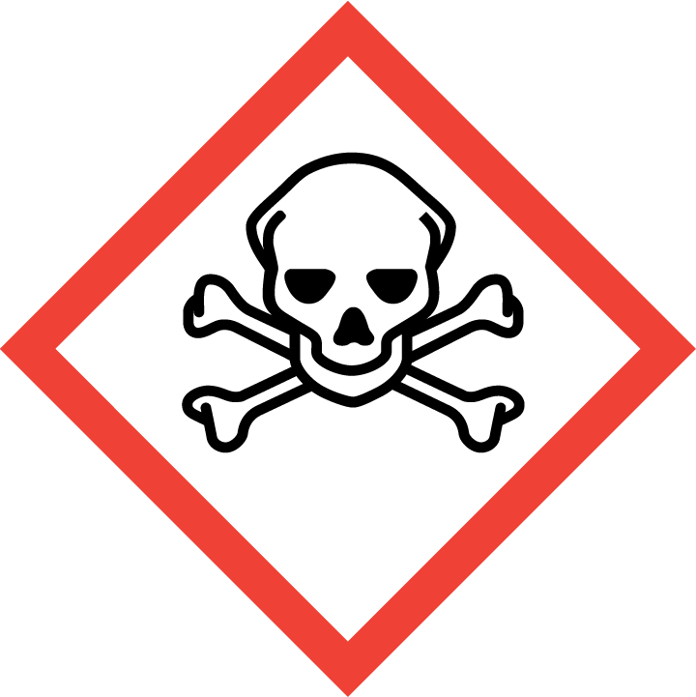  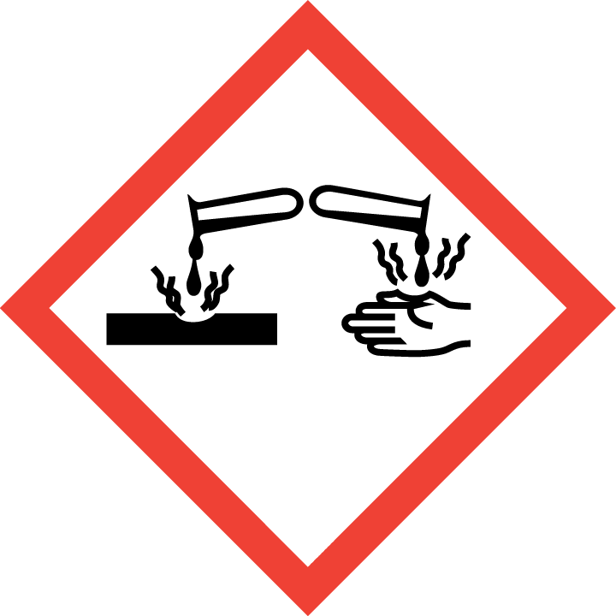
Significant hazards:

HF
Risks from user experiment
Hazard phrases (R):
H300, H330,
H310, H314
Can it be done out of hours?

No HF work should be carried out after hours. Solutions containing HF can be left overnight if suitably prepared.
This SOP is not relevant in the following circumstances:
- SOP does not cover specific experimental risk these must be covered by user’s assessments
- Any others situation where the procedure may result in harm to yourself or others.

Standard Operating Procedure for:  HF spillage | PPE required:
Introduction
HF can cause death through hypocalcaemia. It can cause severe burns and blistering which may not be immediately painful or visible with symptoms potentially delayed 12 - 24 hours after exposure. Expose of any kind requires hospital care.
Before dealing with a spillage you must have undergone training and safety awareness in handling and using HF and risk assessment your experiment. The minimum protection required is a laboratory coat, two pairs of gloves (gauntlet nitrile gloves and gauntlet neoprene gloves), safety glasses, an apron, and a face shield. All work should be carried out in a specifically designed fume cupboard. HF waste should never be stored in glass containers, or with incompatible chemicals.
Minor spillage  In case of a minor spillage (<200ml) deal with only if you feel comfortable. Otherwise, make sure area is safe and then contact your named person.  - Spread dry sodium bicarbonate liberally over the spillage and mop up cautiously with water.  - If necessary spillage can be “blocked” by vermiculite (there is a pot full of it in spill kit next to the fume cupboard) and then neutralized by saturated sodium carbonate  - Run this to waste sink diluting greatly with copious amounts of running water  OR  - If spill is of dilute HF, soak up with HF compatible spill pillow or neutralise with sodium bicarbonate, transfer to polyethylene container and dispose of through the School of Chemistry's hazardous waste disposal system (via the hazardous waste officer)  Major spillage  In case of a major spill (>200ml) evacuate the laboratory. Do not attempt to clean up as inhalation risk may be high.  - Contact your named person or another of the emergency contacts below and contact Security on 32222  - If you are appropriately trained don appropriate respirator and full PPE (see above) but only when another trained person is present.  - Spread sodium bicarbonate liberally over the spillage and mop up cautiously with water.  - Run this to waste diluting greatly with copious amounts of running water  OR  - If spill is of dilute HF, soak up with HF compatible spill pillow or neutralise with sodium bicarbonate, transfer to polyethylene container and dispose of through the School of Chemistry's hazardous waste disposal system (via the hazardous waste officer)  In an emergency contact one of the following personnel:  Andy Connelly 30166 07850190627  David Banks 35244 / 31647  Sarah Burdall 38042 0750 6707339  Jerry Lee 345245 07789271418  Health and Safety services 34201 | Hazard symbols:
Significant hazards:

HF
Risks from user experiment
Hazard phrases (R):
H300, H330,
H310, H314
Can it be done out of hours?

No HF work should be carried out after hours.
This SOP is not relevant in the following circumstances:
- SOP does not cover specific experimental risk these must be covered by user’s assessments
- Any others situation where the procedure may result in harm to yourself or others.

Standard Operating Procedure for:  HF exposure | PPE required:
Introduction
HF can cause death through hypocalcaemia. It can cause severe burns and blistering which may not be immediately painful or visible with symptoms potentially delayed 12 - 24 hours after exposure. Expose of any kind requires hospital care.
Before dealing with a case of HF exposure you must have undergone training and safety awareness in handling and using HF. The minimum protection required is a laboratory coat, two pairs of gloves (gauntlet nitrile gloves and gauntlet neoprene gloves), safety glasses, an apron, and a face shield. All work should be carried out in a specifically designed fume cupboard.
IF IN DOUBT RINSE CONTINUOUSLY WITH WATER.
Any form of contact  This includes small volumes in contact with skin. Ensure you are wearing all appropriate PPE (see above).Do not help casualty without wearing appropriate PPE (gloves, lab coat, and safety glasses are a minimum). Remember symptoms may be delayed up to 24 hours depending on the concentration of HF.  - Rinse the affected area continuously under a tap with copious amounts of water.  - Shout to alert others and ask them to alert one of the named people below and contact University Security on 32222.  - Remove any contaminated clothing and remove casualty from hazardous area  - Contact the A&E department of the LGI and inform them that a casualty with HF burns will be attending. Accompany the casualty to the local hospital along with the HF exposure letter (copies attached to fume cupboard) which has details of how to deal with HF exposure.  - If it is a serious exposure call an ambulance.  - Clear all non-emergency response people from area.  - Keep the affected area under running water for minimum 5mins then rub calcium gluconate into the area until further medical assistance arrives (PPE required).  Eye contact  Immediately flush the eye and face with water keeping the eye lid open and the head to the side away from the other eye. Continue for at least 15 minutes. Calcium gluconate gel should NOT be applied to the eyes.  Ingestion  Wash out mouth with water, (do not swallow washings). Give water or milk to drink. Do not induce vomiting  Inhalation:  Remove to fresh air immediately. Resuscitate if necessary USING A MOUTH GUARD. Keep warm  In an emergency contact one of the following personnel:  Andy Connelly 30166 07850190627  David Banks 35244 / 31647  Sarah Burdall 38042 0750 6707339  Jerry Lee 345245 07789271418  Health and Safety services 34201 | Hazard symbols:
Significant hazards:

HF

Risks from user experiment
Hazard phrases (R):
H300, H330,
H310, H314
Can it be done out of hours?

No HF work should be carried out after hours.
This SOP is not relevant in the following circumstances:
- SOP does not cover specific experimental risk these must be covered by user’s assessments
- Any others situation where the procedure may result in harm to yourself or others.

Standard Operating Procedure for:  Cleaning fume cupboard | PPE required:          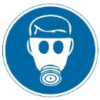
Introduction
This document sets out the procedure for cleaning the HF fume cupboards.

HF can cause death through hypocalcaemia. It can cause severe burns and blistering which may not be immediately painful or visible with symptoms potentially delayed 12 - 24 hours after exposure. Expose of any kind requires hospital care.

PPE for this process should include: impermeable shoes, two pairs of chemical resistant gloves (gauntlet style), and safety goggles. Optional PPE included full body disposable suit, and a half-mask respirator with gas filter (ABEK) attached. Cleaning the fume cupboard should be done with a saturated solution of sodium carbonate (NOT DETERGENT as this may contaminate experiments).

*A= organic gases, B= inorganic gases, E= acid vapours, K= ammonia
Preparing for work  Ensure you are wearing all appropriate PPE (see above).  - Inform your named person (buddy) that you are about to work with HF; they must check on you at least every 20mins.  - Place signs up to let others know HF work is in progress, and tell anyone else working in the lab that HF work is in progress,  - Make sure that calcium gluconate gel is available (and in date) in the local first aid kit,  - Check integrity of PPE including a check of the gloves for pin holes and the respirator for leaks,  - Check there is sodium bicarbonate solution for neutralising spills and washing down PPE before removal and check a spill kit is available,  - Remove all chemicals from the fume cupboard and store in a safe place,  - Ensure all equipment and chemicals are ready before starting work.  Cleaning the fume cupboard  Ensure you are wearing all appropriate PPE (see above).  - With a cloth wipe all surfaces (inside and out including sash) of the fume cupboard with a saturated solution of sodium carbonate (NOT DETERGENT as this may contaminate experiments),  - Any excess solution and the run off can go down sink with plenty of water  - Dispose of cloth in the laboratory waste  - Once all surfaces are wiped with this solution wipe again with DI water, again, run off can go down sink with plenty of water  - Return chemicals to fume cupboard  - Neutralize and clean up any spills and leaving tap running in sink for several hours.  After work  - Wipe down all equipment and surfaces with a solution of saturated sodium bicarbonate followed by water.  - Neutralise the gloves and the working space with saturated sodium bicarbonate and rinse the gloves with copious amounts of water  - Dispose of waste material through the appropriate waste streams ensuring all possible HF contamination has been neutralised,  - Remove unnecessary signage from the fume hood and doors.  - Inform your named person(s) (buddy) that you have completed the work.  Any spillage or exposure please follow appropriate procedures set out in SOPs. | Hazard symbols:
Significant hazards:

HF

Hazard phrases (R):
H300, H330,
H310, H314
Can it be done out of hours?

No HF work should be carried out after hours.

This SOP is not relevant in the following circumstances:
- Any others situation where the procedure may result in harm to yourself or others.

Standard Operating Procedure for:  Handling recirculating tank | PPE required:
Introduction
This document sets out the procedure for neutralizing the 30L recirculating tank, cleaning the filter. These activities should be carried out monthly. You should only need to drain the recirculating tank before external maintenance of the fume cupboard.
Risk assessments and COSHH assessments for this procedure are covered by those written for general handling of HF. HF can cause death through hypocalcaemia. It can cause severe burns and blistering which may not be immediately painful or visible with symptoms potentially delayed 12 - 24 hours after exposure. Expose of any kind requires hospital care.
PPE for this process should include: impermeable shoes, two pairs of chemical resistant gloves (gauntlet style), and safety goggles. Optional PPE included full body disposable suit, and a half-mask respirator with gas filter (ABEK) attached. Cleaning the fume cupboard should be done with a saturated solution of sodium carbonate (NOT DETERGENT as this may contaminate experiments).
*A= organic gases, B= inorganic gases, E= acid vapours, K= ammonia
Preparing for work  Ensure you are wearing all appropriate PPE (see above).  - Inform your named person (buddy) that you are about to work with HF; they must check on you at least every 20mins.  - Place signs up to let others know HF work is in progress, and tell anyone else working in the lab that HF work is in progress,  - Make sure that calcium gluconate gel is available (and in date) in the local first aid kit,  - Check integrity of PPE including a check of the gloves for pin holes and the respirator for leaks,  - Check there is sodium bicarbonate solution for neutralising spills and washing down PPE before removal and check a spill kit is available,  - Remove all chemicals from the fume cupboard and store in a safe place,  - Ensure all equipment and chemicals are ready before starting work.  - If required measure the pH f the recirculating tank with pH paper  Neutralizing recirculating tank  Ensure you are wearing all appropriate PPE (see above).  - If microbiological contamination is a concern add 600ml of tri-gene to the tank (making a 2% solution) 30mins before starting.  - If significant HF acid content is a concern remove lid of tank and sprinkle 50g boric acid powder over the surface of the water (50g assuming 0.1M HF present in 30L)  - Run the scrubbers to circulate the boric acid around the system.  - Measured the pH of the tank with pH paper.  - If it is lower than pH 5.5 add a small amount (e.g. 50g) of Na₂CO₃ to the tank and watch for bubbling. Be careful not to add too much and cause spillover of bubbles/solution.  - Repeat additions over such a period until no fizzing occurs when more is added and the pH of the solution (measured with pH paper is greater than pH 5.5).  Cleaning the filter  Ensure you are wearing all appropriate PPE and have materials ready for small spillage (see above).  - Close the valves either side of the pump  - Rotate the pipe (see diagram) so the filter is pointing upwards  - Unscrew the filter SOME WATER WILL ESCAPE  - Clean the filter in the fume cupboard sink by running water over it  - Replace the filter and reopen the valves.  Draining recirculating tank  This should only need doing if external people are coming to work on the cupboard. Ensure you are wearing all appropriate PPE and that the tank has been neutralized (see above).  - Turn on the backwash tap (top right outside fume cupboard) to clean off the scrubbers and demisters. Leaving this running overnight. This will replace solution in tank with clean water. If leak is detected neutralize unless it is a significant leak then stop process and go on to Draining Recirculation Tank.  - Stop/isolate the pump (Valve A)  - Close the ball valve located in the recirculation pipe (Valve B)  - The self-filling ball valve should be isolated to prevent the tank re-filling. This is at the back (follow white tube).  - NEVER ALLOW THE PUMP TO RUN DRY  - Using a syphon transfer the contents of the tank to two 20L plastic containers.  - If the backwash process was successful (see above) the contents of these plastic containers can go down the drain. However, if the backwash process was not successful please dispose of these containers as waste.  After work  - Wipe down all equipment and surfaces with a solution of saturated sodium bicarbonate followed by water.  - Neutralise the gloves and the working space with saturated sodium bicarbonate and rinse the gloves with copious amounts of water  - Dispose of waste material through the appropriate waste streams ensuring all possible HF contamination has been neutralised,  - Remove unnecessary signage from the fume hood and doors.  - Inform your named person(s) (buddy) that you have completed the work.  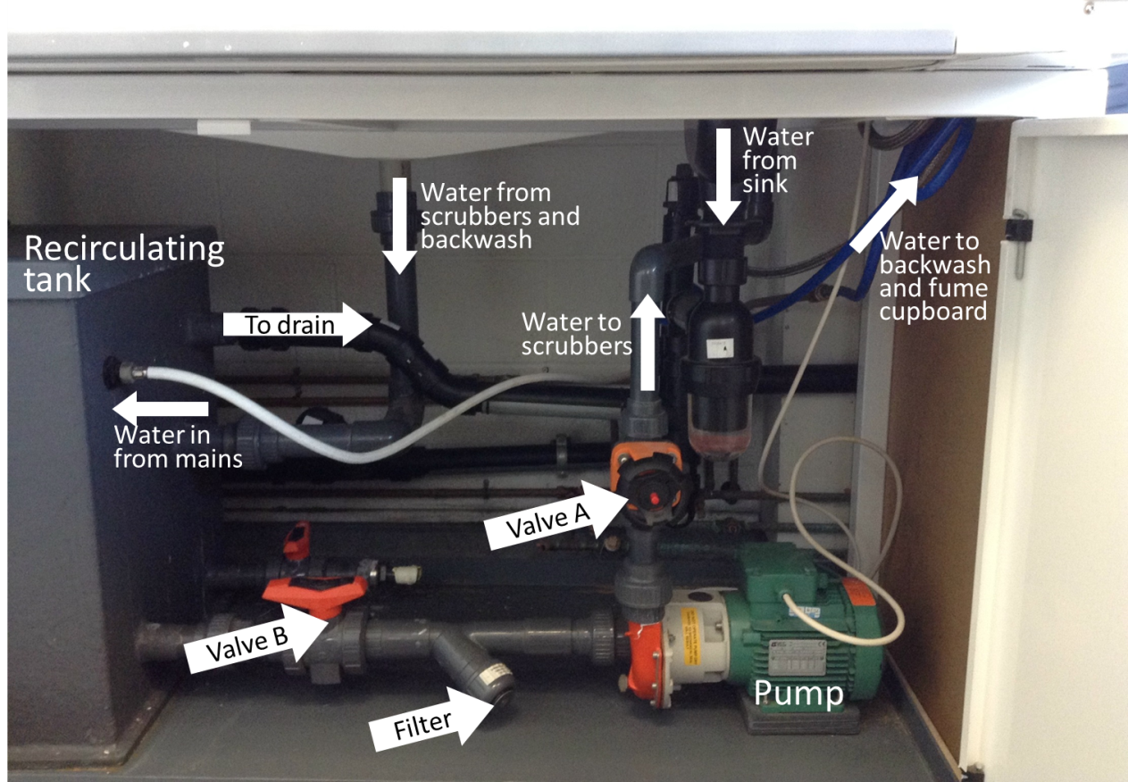  Any spillage or exposure please follow appropriate procedures set out in SOPs. | Hazard symbols:
Significant hazards:

HF

Hazard phrases (R):
H300, H330,
H310, H314
Can it be done out of hours?

No HF work should be carried out after hours.
This SOP is not relevant in the following circumstances:
- Any others situation where the procedure may result in harm to yourself or others.

