Standard Operating Procedure for:  Using mechanical pipettors | PPE required:      
Pipettors are high precision, accurate devices which should be handled only after appropriate training. Please take care of the pipettors as they are used by many people in the labs and are very expensive to replace and repair. Some pipettors are dedicated to specific procedures (e.g. within the microbiology safety cabinet); these must never be used for any other procedures; check if unsure.
If possible, pipettors should be stored in a vertical position when not in use. The volume range is shown on the top or side of the pipettor; do not attempt to set volumes outside the pipettes specialised volume range. Cohen pipettors are serviced annually. If you need to calibrate your pipettor between services or you are getting strange results please ask a technician.
Prior to use  - Check the pipettor for dirt and damage:  - If dirty on the outside use 70% ethanol to clean,  - If the tip of the cone is damaged report pipette to a technician.  - Find the correct pipette tips for the pipettor you are using. If in doubt ask a technician.  - Allow liquids and equipment to equilibrate to ambient temperature before pipetting. Avoid handling pipette tips and the barrel of pipettor as the heat can alter the pipetted volume.  Good techniques  - Check your risk assessment for any hazards in your experiment.  - Fit the pipette tip wearing the appropriate PPE.  - Pre-wet the pipette tip by aspirating and expelling an amount of the sample liquid 3 times before aspirating a sample for delivery. There is a difference of up to 10% in the volume taken up by a “dry” tip than a “wet” tip.  - Do not lay the pipette down when a filled pipette tip is attached.  - Make sure all spills are cleaned up as you go along and that all used pipette tips go into the pointy plastics orange bin.  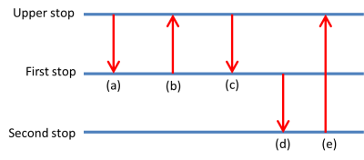  Forward (normal) mode pipetting  - Hold the pipette vertically; depress the operating button to the first stop (a).  - Place the tip just under the surface of the liquid (2-5mm) and smoothly release the operating button (b).  - Carefully withdraw the tip from the liquid, touching against the edge of the container to remove excess.  - To dispense the liquid, hold the tip at an angle of around 30-45º against the wall of the receiving container. Depress the operating button to the first stop (c) and hold for one second.  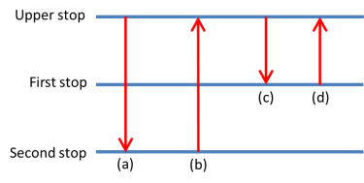  - Push the pipette to the second stop (d) while sliding the pipette against the walls of the container. This second depressing of the operating button is known as the “Blow out” function. Releasing the operating button at this point returns it to its uppermost position (e).  Reverse mode pipetting  The reverse mode is used when working with viscous and volatile liquids.  - Depress the operating button to the second stop (a) and place the tip 2-5mm into the liquid, remembering to hold the pipette vertically.  - Release the operating button smoothly to the upper stop (b). This may take a little time when using viscous liquids. If your procedure allows, wipe excess from the outer surface of the tip or touch against the edge of the container to remove excess.  - In order to dispense the liquid, depress the operating button to the first stop only, (c). Hold the operating button at the first stop. The liquid that remains in the tip should not be included in the delivery.  - To ensure that the correct volume is delivered the liquid remaining in the tip should be discarded with the tip. Releasing the plunger at this point returns it to its uppermost position (d). | Hazard symbols:  See individual experiment risk assessments
Significant hazards:

See individual experiment risk assessments
.
 | Hazard phrases (H):
Can it be done out of hours?

Mechanical pipettors can be used out of hours unless individual experimental risks do not allow.
This SOP is not relevant in the following circumstances:
- SOP does not cover specific experimental risk these must be covered by user’s assessments
- Any other situation where the procedure may result in harm to yourself or others.

