Standard Operating Procedure for:  Total Carbon Content by LOI | PPE required:      
Introduction
This method covers the semi quantitative determination of Total Carbon content in soils and sediments. By measuring organic and inorganic carbon contents:
Total carbon = inorganic carbon + organic carbon
Inorganic carbon is generally in the form of carbonates. Here we use two separate heating stages (LOI – loss on ignition) to remove first the organic carbon and second the inorganic carbon at a higher temperature. This method assumes all LOI is due to carbon – this may not be accurate.
Preparing samples  - Grind and sieve samples if required using a pestle and mortar and sieves (any other grinding method requires a separate Risk Assessment).  - Place the sample (approximately 5 g to 10 g) in a small crucible  - Place the crucible in an oven at 60ºC overnight to remove all water. Some samples may take longer to dry.  - Remove samples from oven and allow to cool. This could be carried out in a desiccator.  - If the sample needs homogenization a further homogenization step with a pestle and mortar can be carried out and sieving if required.  - Store dried samples in sealed container.  Ashing of samples for organic carbon  If you want to remove organic carbon from your sample then.  - Using a 4-place balance weigh crucibles and record mass (m_{cruc}).  - Place up to approx. 1g of sample into small crucibles record mass (m_{initial})  - Place crucibles into furnace at 440ºC overnight. This temperature is used to avoid destruction of carbonates  - Once crucibles have cooled (HOT! WEAR GLOVES) remove from furnace and reweigh (m_{final1}).  - Calculate the mass change m_{TOC}=(m_{initial} – m_{cruc}) - m_{final1}  - where m_{TOC}= total organic carbon  Ashing of samples for inorganic carbon  If you want to remove inorganic carbon from your sample then.  - Taking the sample crucibles as above replace them in furnace over night at 1000ºC.  - Once crucibles have cooled (HOT! WEAR GLOVES) remove from furnace and reweigh (m_{final2})  - Calculate the mass change m_{TIC}=m_{final1}- m_{final2}  - where m_{TIC}= total inorganic carbon  - The total carbon can thus be calculated m_{TC}=m_{TOC} + m_{TIC} | Hazard symbols:  See risks from individual experiments.
Significant hazards:
Very high temperatures
Hazard phrases (H):
See risks from individual experiments.
Can it be done out of hours?

Furnaces should not be opened when hot out of hours. However, furnaces can be left on overnight.
This SOP is not relevant in the following circumstances:
- SOP does not cover specific experimental risk these must be covered by user’s assessments
- Any others situation where the procedure may result in harm to yourself or others.

Standard Operating Procedure for:  Total Carbon using LECO | PPE required:      
This method covers the determination of Total Carbon (TC) in sediments or soils by measuring total and organic carbon content (TC and TOC). The amount of carbon is determined by dry combustion with an infrared carbon analyser (LECO). Sediments that contain inorganic carbon are first treated with acid to remove the inorganic carbon (usually carbonate) and then analyzed for TOC. Some forms of inorganic carbon (e.g., Dolomite) may be difficult to remove from the soil by acid treatment. Incomplete removal inorganic carbon will lead to high bias in the TOC results.
Preparing samples  This is an optional step to dry samples and measure water present.  - Grind and sieve samples if required using a pestle and mortar and sieves (any other grinding method requires a separate Risk Assessment).  - Place the sample (approximately 5 g to 10 g) in a small crucible  - Place the crucible in an oven at 60ºC overnight to remove all water. Some samples may take longer to dry.  - Remove samples from oven and allow to cool. This could be carried out in a desiccator.  - If the sample needs homogenization a further homogenization step with a pestle and mortar can be carried out and sieving if required.  - Store dried samples in sealed container.  Removal of inorganic carbon  There are several different acids that can be used for this process (see below); however, the process is the same for each.  - Using a 4-place balance weigh centrifuge tube and record mass (m_{tube}).  - Place 1-5g of sample into tube record mass (m_{initial})  - Wearing appropriate PPE. Add about 5ml of dilute acid to the centrifuge tube and mix thoroughly. Beware of CO₂ production and foaming.  - Keep adding small amounts of dilute acid until fizzing stops then add another 5ml to ensure acid is in excess.  - Place samples in the fume cupboard and clearly label. Wait at least overnight for reaction to cease. Some carbonate minerals take a long time to react e.g. siderite. If you know these are present wait at least 24 hours or use a second acid rinse.  - Wait for sediment to settle out.  - Decant off as much of the clear liquid ensuring none of the soil/sediment is lost. This can be done with a pipette or a syringe and tube. It may require use of a centrifuge (see appropriate risk assessment and training).  - Collect leachate (dilute acid) in a waste bottle and label ready for disposal. DO NOT POUR DOWN SINK.  - Re-fill tube with distilled water to wash acid from sample. You can shake tube but be careful not to lose any sample. Separate sample and water as in Step 7. This leachate can be disposed of down sink.  - After third rinse check the pH of the leachate of some representative samples using pH paper. If it is greater than pH 4 then remove water as in Step 7 and go to Step 11. Otherwise repeat washing.  - Allow sample to dry in an oven at 60ºC overnight.  - Weigh centrifuge tube and sample again (m_{Final})  - Calculate the mass change m_{lost}=(m_{initial} – m_{tube}) - (m_{final} – m_{tube})  - where m_{lost}= is mass lost including carbonate and other soluble elements (e.g. Ca)  Measurement of organic carbon  This uses the LECO carbon/sulphur analyser. This equipment requires separate Risk Assessment and training.  - Take appropriate amount of dried original sample and analyse for percentage carbon (and sulphur if required) this will give you TC.  - Take appropriate amount of dried and treated (inorganic free) sample and analyse for percentage carbon (and sulphur if required). This is the percentage (P_{OC}) in your treated sample NOT the TOC – a calculation is required.  Calculations  To calculate the TOC and TIC (Total Inorganic Carbon) accurately the following calculations are required. They use the measured masses from acid washing:  - TOC = P_{OC} * ((m_{Final} – m_{tube})/ (m_{Initial}– m_{tube}))  - TIC = TC - TOC  Choice of acid and preparation  There are various acids you can use in this process:  - HCl – 1-2 molar HCl (normally 10% (1.3M)) – This is the standard acid used in this process. While it may will destroy some organic carbon compounds it is a reducing acid and so less destructive than other acids (e.g. nitric acid). The Cl in this acid can also cause problems for the LECO and so sample cleaning is very important.  - H₂SO₄ – 2 molar – This acid does not have same problems for LECO so cleaning is not as necessary; however, it is a oxidising acid so may significantly attack organic phases.  - Other acids may be used but these will require separate Risk and COSHH assessments  Preparation of acid  For all acid solution preparation full PPE should be worn including a second pair of chemical resistant gloves and it must be carried out in a fume cupboard.  - Measure out the appropriate amount of water into a clearly labelled container (plastic or glass);  - Using a measuring cylinder or appropriate acid resistant pipette measure out the appropriate amount of concentrated acids.  - Mix thoroughly. | Hazard symbols:  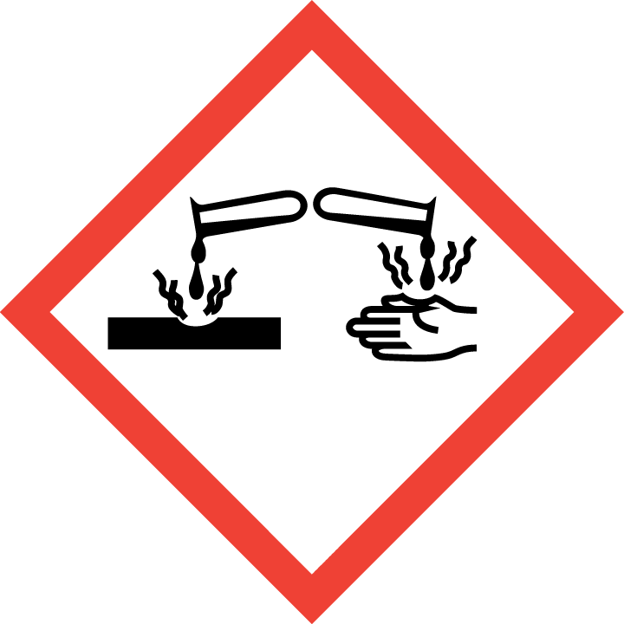  See risks from individual experiments.
Significant hazards:
Concentrated acids
Hazard phrases (H):
See risks from individual experiments.
Can it be done out of hours?

Due to the use of concentrated acids and high temperature equipment this process should not be performed out of hours.
This SOP is not relevant in the following circumstances:
- SOP does not cover specific experimental risk these must be covered by user’s assessments
- Any others situation where the procedure may result in harm to yourself or others.

