Standard Operating Procedure for:  Vacuum Filtration | PPE required:      
This SOP is for Vacuum filtration Using vacuum/Büchner flasks. The vacuum can be drawn by an electric vacuum pump or by a water tap attachment.
There are different types of funnel available. The single piece (Büchner) funnel and the 2/3 piece clamped funnel. The clamped funnel creates a seal over the edges of the filter so that it is not able to lift and material cannot be washed under the filter.
This SOP is for water only, acids, volatile fluids or those evolving corrosive gases require further risk assessment.
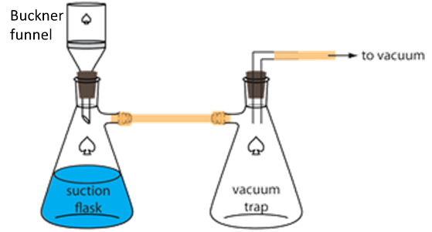  Setting up the flask  - Inspect all glassware for damage or debris before use. Damage, could lead to an implosion. Also, check tubing for damage and that seals are fit for purpose.  - Consider the type of solution and volume you are about to filter and chose an appropriate type and size of flask and funnel.  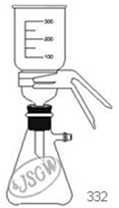  - Check your method for the most appropriate filter type (e.g. size of pores required, material compatibility, diameter, etc.).  - Attach tubing to the flask, ensure you have a second flask to act as a trap to prevent liquid entering the vacuum pump.  Filtering the suspension  - Place the lower portion of the glass funnel or the sinter into the top opening of the flask. Or the whole Büchner funnel.  - If using a membrane filter, use tweezers/forceps to place the filter on the support. Some filters need damping with a fluid similar to the filtrate to help it stay in position.  - *Place the upper portion of the funnel so that it is aligned to the lower portion. Avoiding sliding and turning as this will damage the filter.  - *Place the clamp over the join of the upper and lower parts of the funnel  - Stabilise the apparatus with a clamp stand near the vacuum source.  - Turn on the water or electric vacuum pump.  - Visually check and listen for any signs of excessive strain or leaks.  - Pour a small volume of suspension into the funnel to allow the filter to wet. This will also allow you to check for other problems before adding larger volumes.  - Pour the suspension into the funnel in manageable volumes until all is through or the receiving flask is full to approx. 2cm below the outlet arm.  - Or, if the filter becomes blocked or is spent replace the filter before continuing by dismantling the funnel and placing a clean filter in place and/or cleaning the sinter.  - When filtering is finished, turn off the vacuum source and disconnect the tubing.  - Separate the glassware and decant the filtrate pouring away from the vacuum outlet.  - Clean the glassware and leave to dry.  * - indicates step not necessary if using a single piece Büchner funnel | Hazard symbols:  See individual experiment SOP
Significant hazards:
Implosion.
Experiment specific hazards
 | Hazard phrases (R):
Can it be done out of hours?

Refer to specific SOP Risk Assessment
This SOP is not relevant in the following circumstances:
- Volatile fluids or those evolving corrosive gases. Additional risk assessment must be made.
- SOP does not cover specific experimental risk these must be covered by user’s assessments
- Any other situation where the procedure may result in harm to yourself or others.

